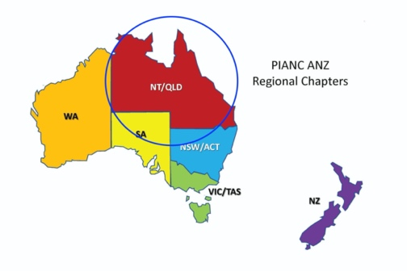
Expression of interest for PIANC Australia and New Zealand’s QLD/NT Chapter
Expressions of interest are invited from PIANC ANZ members for the positions of Chair or Committee Member for our QLD/NT Chapter.
To apply, please complete the details and brief supporting statement below outlining your suitability for the position/s and email to the Chapter Contact along with a copy of your CV.
For more information, please contact the Chapter Contact, Kevin Kane on 07 4969 0734 or by email at kkane@nqbp.com.au.
Expressions of interest need to be received by close of business on Friday 16 April 2021.
Contact Details
* First name: Click or tap here to enter text.
* Surname: Click or tap here to enter text.
* Email address: Click or tap here to enter text.
* Daytime telephone number: Click or tap here to enter text.
* Are you a PIANC / ANZ Member: Choose an item.
* Are you a Young Professional (PIANC member under 40) Choose an item.
* What position are you interested in: Choose an item.

Brief Supporting Statement
Please provide a brief statement outlining the relevant qualifications and experience that you would bring to the role.
Click or tap here to enter text.

